ECA3101-NANO ELECTRONICS
Exp. 5. Band Structure Simulation for Graphene and CNTs using NanoHub
TEST CASE-1: band-structure of InAs circular nanowire
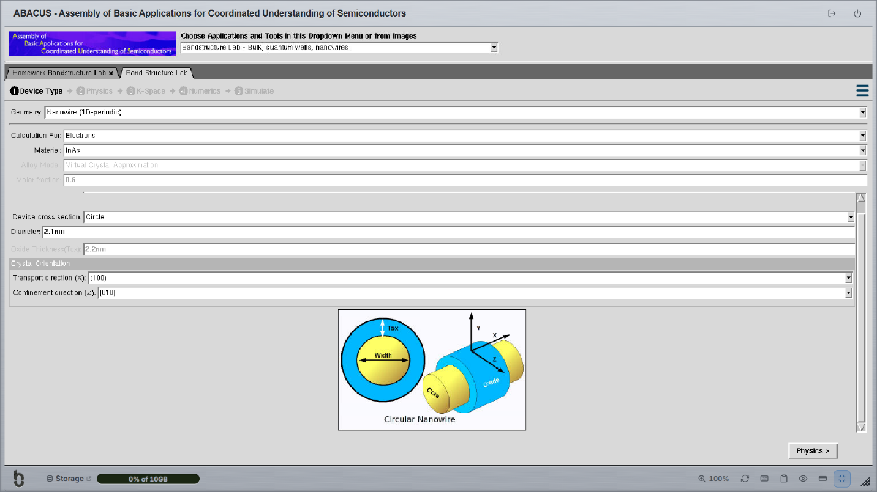
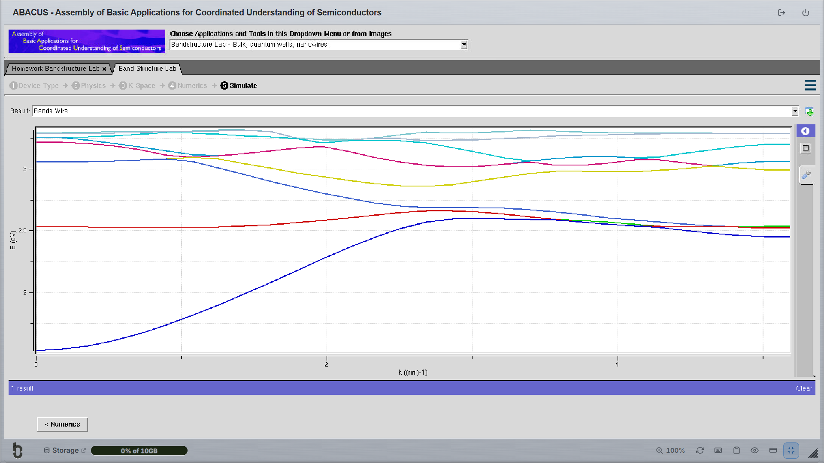
TEST CASE-1: band-structure of AlGaAs circular nanowire


